**Results for ML model training over HMM data**

**Bayesian Network**

|  |  |  |  |  |  |  |
| --- | --- | --- | --- | --- | --- | --- |
|  |  | **Classification** | | | | |
|  | **Class** | Happy | Interested | Sad | Worried | Stern |
| **True Class** | Happy | 46 | 12 | 1 | 2 | 0 |
| Interested | 31 | 117 | 1 | 8 | 0 |
| Sad | 0 | 5 | 0 | 7 | 0 |
| Worried | 0 | 8 | 2 | 25 | 0 |
| Stern | 0 | 1 | 0 | 9 | 0 |

Correctly Classified Instances 188 68.3636 %

Incorrectly Classified Instances 87 31.6364 %

**Naïve Bayes**

|  |  |  |  |  |  |  |
| --- | --- | --- | --- | --- | --- | --- |
|  |  | **Classification** | | | | |
|  | **Class** | Happy | Interested | Sad | Worried | Stern |
| **True Class** | Happy | 23 | 36 | 0 | 2 | 0 |
| Interested | 20 | 129 | 0 | 8 | 0 |
| Sad | 0 | 11 | 0 | 1 | 0 |
| Worried | 0 | 10 | 0 | 22 | 3 |
| Stern | 0 | 1 | 0 | 9 | 0 |

Correctly Classified Instances 174 63.2727 %

Incorrectly Classified Instances 101 36.7273 %

**Logistic regression**

|  |  |  |  |  |  |  |
| --- | --- | --- | --- | --- | --- | --- |
|  |  | **Classification** | | | | |
|  | **Class** | Happy | Interested | Sad | Worried | Stern |
| **True Class** | Happy | 36 | 23 | 0 | 2 | 0 |
| Interested | 25 | 124 | 0 | 8 | 0 |
| Sad | 0 | 10 | 0 | 2 | 0 |
| Worried | 0 | 10 | 0 | 21 | 4 |
| Stern | 0 | 1 | 0 | 9 | 0 |

Correctly Classified Instances 181 65.8182 %

Incorrectly Classified Instances 94 34.1818 %

**Multilayer Perceptron / Neural net, one layer**

|  |  |  |  |  |  |  |
| --- | --- | --- | --- | --- | --- | --- |
|  |  | **Classification** | | | | |
|  | **Class** | Happy | Interested | Sad | Worried | Stern |
| **True Class** | Happy | 34 | 24 | 1 | 2 | 0 |
| Interested | 28 | 120 | 1 | 8 | 0 |
| Sad | 0 | 5 | 2 | 5 | 0 |
| Worried | 0 | 8 | 2 | 22 | 3 |
| Stern | 0 | 1 | 0 | 9 | 0 |

Correctly Classified Instances 178 64.7273 %

Incorrectly Classified Instances 97 35.2727 %

**K-nearest neighbors (1 neighbor, performance degrades with more neighbors)**

|  |  |  |  |  |  |  |
| --- | --- | --- | --- | --- | --- | --- |
|  |  | **Classification** | | | | |
|  | **Class** | Happy | Interested | Sad | Worried | Stern |
| **True Class** | Happy | 43 | 16 | 0 | 2 | 0 |
| Interested | 31 | 117 | 1 | 8 | 0 |
| Sad | 0 | 11 | 0 | 1 | 0 |
| Worried | 0 | 12 | 1 | 19 | 3 |
| Stern | 0 | 1 | 0 | 9 | 0 |

Correctly Classified Instances 179 65.0909 %

Incorrectly Classified Instances 96 34.9091 %

**Random Forest**

|  |  |  |  |  |  |  |
| --- | --- | --- | --- | --- | --- | --- |
|  |  | **Classification** | | | | |
|  | **Class** | Happy | Interested | Sad | Worried | Stern |
| **True Class** | Happy | 41 | 17 | 1 | 2 | 0 |
| Interested | 31 | 117 | 1 | 8 | 0 |
| Sad | 1 | 6 | 3 | 2 | 0 |
| Worried | 0 | 9 | 2 | 20 | 4 |
| Stern | 0 | 1 | 0 | 7 | 2 |

Correctly Classified Instances 183 66.5455 %

Incorrectly Classified Instances 92 33.4545 %

**SVM (linear kernel)**

|  |  |  |  |  |  |  |
| --- | --- | --- | --- | --- | --- | --- |
|  |  | **Classification** | | | | |
|  | **Class** | Happy | Interested | Sad | Worried | Stern |
| **True Class** | Happy | 46 | 13 | 0 | 2 | 0 |
| Interested | 31 | 118 | 0 | 8 | 0 |
| Sad | 0 | 8 | 0 | 4 | 0 |
| Worried | 0 | 10 | 0 | 22 | 3 |
| Stern | 0 | 1 | 0 | 9 | 0 |

Correctly Classified Instances 186 67.6364 %

Incorrectly Classified Instances 89 32.3636 %

**SVM (polynomial kernel)**

|  |  |  |  |  |  |  |
| --- | --- | --- | --- | --- | --- | --- |
|  |  | **Classification** | | | | |
|  | **Class** | Happy | Interested | Sad | Worried | Stern |
| **True Class** | Happy | 14 | 45 | 0 | 2 | 0 |
| Interested | 15 | 134 | 0 | 8 | 0 |
| Sad | 0 | 11 | 0 | 1 | 0 |
| Worried | 0 | 10 | 0 | 21 | 4 |
| Stern | 0 | 1 | 0 | 7 | 2 |

Correctly Classified Instances 171 62.1818 %

Incorrectly Classified Instances 104 37.8182 %

**SVM (radial kernel)**

|  |  |  |  |  |  |  |
| --- | --- | --- | --- | --- | --- | --- |
|  |  | **Classification** | | | | |
|  | **Class** | Happy | Interested | Sad | Worried | Stern |
| **True Class** | Happy | 44 | 15 | 0 | 2 | 0 |
| Interested | 31 | 118 | 0 | 8 | 0 |
| Sad | 0 | 7 | 0 | 5 | 0 |
| Worried | 0 | 10 | 0 | 22 | 3 |
| Stern | 0 | 1 | 0 | 9 | 0 |

Correctly Classified Instances 184 66.9091 %

Incorrectly Classified Instances 91 33.0909 %

**SVM (sigmoid kernel)**

|  |  |  |  |  |  |  |
| --- | --- | --- | --- | --- | --- | --- |
|  |  | **Classification** | | | | |
|  | **Class** | Happy | Interested | Sad | Worried | Stern |
| **True Class** | Happy | 0 | 54 | 0 | 7 | 0 |
| Interested | 0 | 145 | 0 | 12 | 0 |
| Sad | 0 | 12 | 0 | 0 | 0 |
| Worried | 0 | 35 | 0 | 0 | 0 |
| Stern | 0 | 10 | 0 | 0 | 0 |

Correctly Classified Instances 145 52.7273 %

Incorrectly Classified Instances 130 47.2727 %

**Some things to note:**

* The data was not classified by task, only by previous emotion and valence and arousal for neutral of positive correlation between the previous and current affect measurements.
* The number of measurements for ‘interested’ robot emotion outweighed all over emotions, namely, more than half of the robot’s emotions were ‘interested’, thus, there is a bias of 50% probability that the emotion is ‘interested’
* With the bias term, the best improvement is about 20% in the case of the bayesnet.
* I don’t think this data shows accuracy in the ML methods, mostly because the majority of the classification data is for ‘interested’ emotion with a previous emotion of ‘interested’ and an arousal of ‘0’ (the valence and arousal values where offset to [0,5] instead of [-2,2] as some of the Bayes classifiers required positive values)
* Figure 1 represents the visualization of the input data, which illustrates the disparity between the amount of data for ‘interested’ to all other emotions.

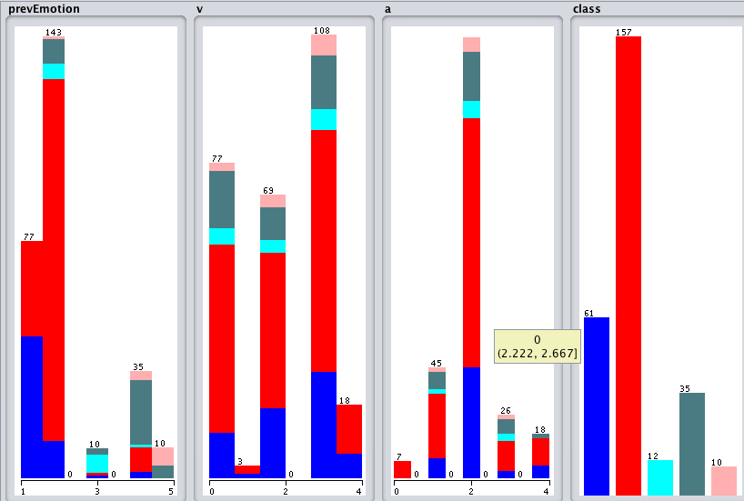

Figure 1: Distribution of input data